
In His Sign Catholic Radio
Annual Wake Up America Dinner

Sunday, April 26 1:30pm – 5:30pm
Malvern Retreat House 315 South Warren Avenue Malvern, PA 19355

Happy 250th Birthday, America!!

PROCLAIM LIBERTY THROUGHOUT THE LAND UNTO ALL THE INHABITANTS
(Leviticus 25:10)
Kathleen McCarthy is a published author,
International Catholic lay evangelist, and
President of In His Sign Catholic Radio Network.
Spanning more than four decades, Kathleen’s
ministry has produced countless stories of healing
through the power of the Holy Spirit. She is a
renowned conference speaker, retreat master,
broadcaster, and more. Through her gift of
storytelling and prayer, Kathleen shares the fire
of Jesus’ Eucharistic Heart and the message
of God’s Merciful Love.
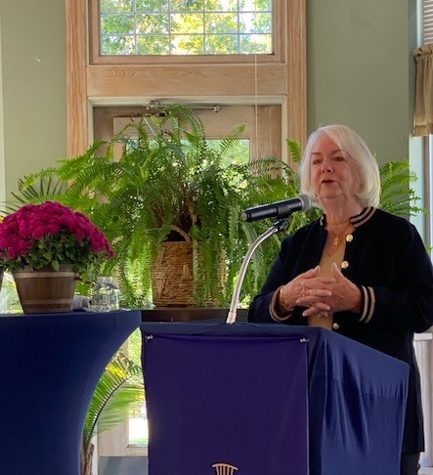
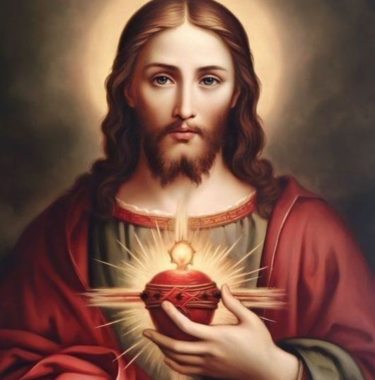

Register for Event!

Please complete the registration form and make check payable to: in his sign catholic radio
mail to:
In His Sign Catholic Radio
136 Garrett Avenue
Rosemont, PA 19010
PLEASE NOTE: TICKETS WILL NOT BE AVAILABLE
FOR PURCHASE AT THE DOOR!

Event highlights include…
Keynote address by Kathleen McCarthy

Meet our radio broadcasters

Silent Auction

Drawings for raffle prizes

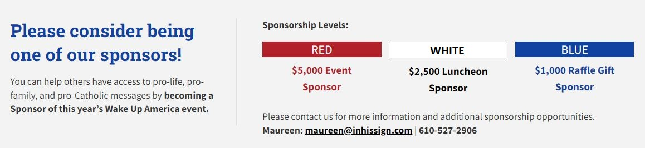

Cost: $55 per person / $100 per couple or $400 for table of 8 WUA 05/22
(Seating is general admission, except for tables of 8 – Reservations must be made in advance.)

Cost: $60 per person / $110 per couple or $450 for table of 8 WUA 04/26
(Seating is general admission, except for tables of 8 – Reservations must be made in advance.)

Please make check payable to IN HIS SIGN CATHOLIC RADIO and mail to 136 GARRETT AVENUE, ROSEMONT, PA 19010
For additional information or to pay by credit card, please call (610) 527-2906 (Discover / MasterCard / Visa are accepted)
**Please include a self-addressed, stamped envelope for return of ticket(s)**

Name: __________________________________________________________________
Address: __________________________________ City:_____________________ State: ______ Zip: _________
Telephone: _______________________________ Email: ________________________________________
# of Single Seats: __________ # of Tables of 8: __________ Total Amount Enclosed: $_____________
I cannot attend, but please accept this donation in the amount of $__________ to support your ministry.

